Oxford AHSN case study
Date: Q3 2019/20
Programme / theme: Strategic and Industry Partnerships
Title: Oxford AHSN Strategyzer workshops helps companies shape their offering to be in-line with NHS needs
Overview Summary
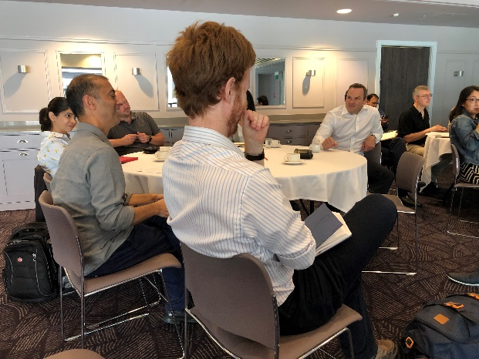
The Oxford AHSN Strategyzer half to one day workshops are run for companies that have a product or innovation and want to explore the viability of their concept for the NHS or want to move into the NHS market.
The Oxford AHSN team work with companies who are struggling to develop their value proposition and work with them to help test their assumptions and shape their offering to be more in-line with proven NHS needs, as well as creating a business model with the aim to facilitate widespread adoption at scale and pace. The Strategyzer workshops help to encourage out-of-the-box thinking that will stand up to scrutiny from both investors and stakeholders alike.
How is the AHSN involved?
The Oxford AHSN team run Strategyzer workshops using tools such as the Value Proposition Canvas, which looks at identifying stakeholders and their requirements to allow innovators to see how well their product matches up. The workshops also use the Business Model canvas, which allows companies to visually map out their business structure, in a light touch way, and see if they have a viable model. Companies are encouraged to go out and test all their key assumptions on these canvases, as part of their customer discovery and to frequently repeat the process to ensure that they remain on track.
Impacts and outcomes of the AHSN involvement to date
The Oxford AHSN Strategyzer workshops have helped companies to validate their assumptions about their customer base and refine their product offering to be more in line with clinical needs, as well as providing innovators with access to NHS clinicians and mentors. This has given them a good understanding of how clinicians and stakeholders within the NHS can benefit from their offering, and how the procurement process works. Companies have been provided with perspective from the NHS stakeholders as to how their solution meets the clinical need, and have frequently adapted their products and business models in response to the information gathered as part of this process.
The participating companies have refined their value proposition for the NHS market and validated their assumptions about commercial access strategies. Alternative key markets have been identified and the companies have used this information to extend their business model, engage with relevant stakeholders and produce deeper market analysis, while continuing to work with Oxford AHSN on pathway mapping for the NHS.
Supporting quotes
Innovator
“The support provided has been invaluable in helping us to understand the dynamics in dealing with the NHS and the interaction between the NHS and social services.”
Bill Palmer, Executive Partner and Founder, Consentricare

“The workshop provided by the Oxford AHSN helped us to look at our customers through a different lens, this made sure we were along the right lines and hitting the customers correctly.”
William Cotton, Trust on Tap

“The programme has been a steep learning curve challenging us to go beyond our comfort zone. It has helped us fine tune our value proposition, thereby ensuring that we are ready to pitch our business model to potential investors.”
Vineeta Tripathi, CEO and Director, Dravya Discovery
AHSN
“The Oxford AHSN supports companies through the process of structured customer and stakeholder discovery, looking at their pains and needs and then how their product or innovation could address these issues. Companies often gain valuable insight from these sessions and create stronger product offerings and businesses as a result.”
Ashley Aitken, Senior Programme Manager, Oxford AHSN
Plans and timescales for spread and adoption
If you are interested in our Strategyzer workshops then please get in touch.

Contact
Matthew Lawrence
Oxford AHSN
matthew.lawrence@oxfordahsn.org

